Pacific Gas and Electric
10.21DB Install Guide
IBM EDGIS Project
Kris Foster
6/5/2015

[Type the abstract of the document here. The abstract is typically a short summary of the contents of the document. Type the abstract of the document here. The abstract is typically a short summary of the contents of the document.]

Contents
SECTION 01: EDER 1
SECTION 02: Multiple Oracle Database Configuration (EDER / EDERSUB) 3
SECTION 03: Configure Electric Geometric Network to use Feeder Manager 2.0 (EDER) 6
SECTION 04: Configure Substation Geometric Network to use Feeder Manager 2.0 (EDERSUB) 7
SECTION 05: Relationship Class Changes (EDER) 9
SECTION 06: EDER Views (EDER / EDERSUB) 11
SECTION 07: Grant Privileges (EDER / EDERSUB) 11
SECTION 08: Process Framework Configuration Changes (EDER) 11
SECTION 09: Create WEBR CircuitSource views (EDER) 12
SECTION 10: Apply permissions for GIS_I (EDERSUB) 13
SECTION 11: Update Cached Tracing Tables (EDER / EDERSUB) 13
SECTION 12: 14

Change Control
Date | Changes Applied | Last Updated By
6/5/2015 | - Added Section Headers  - Added TOC | Kenny Kwong / Michael Uyema

SECTION 01: EDER
All DB upgrade steps must be run from a server with all ArcGIS/ArcFM 10.2.1 software and patches installed (includes ArcSDE 10.2.1 Oracle 64-bit for Windows with the required 11.2.0.3 client for 64-bit to replace the current installed ArcSDE version.)
TFS 21991 lists all required patches.
Install Software and initial configuration:
- Ensure all sessions have been posted to default
- Uninstall all current 10.0.3 components (including custom installers). After uninstall, backup the remaining “PG&E Custom Components” directory to save any current configuration files for reference later. After backed up, delete the “PG&E Custom Components” folder.
- Install all 10.2.1 components (including custom installers).
  - Ensure all ArcGIS patches are installed \\sfetgis-nas01\sfgispoc_data\ApplicationDevelopment\Software\ArcGIS_10_2_1\ArcGIS_Desktop_10.2.1_Patches
  - This includes the ArcSDE 10.2.1 Oracle 64-bit for windows with the required 11.2.0.3 client for 64-bit to replace the current installed ArcSDE version.
  - Refer to individual sections at the end of this document for necessary installation and configuration requirements for all custom installers. Not all installers are necessary for all systems.
- Connect via SQL as SDE and delete any outstanding versions.
DELETE FROM SDE.VERSIONS WHERE NAME <> 'DEFAULT';
- Drop Functional Indices as EDGIS user in sqlplus
$/EDAMGIS/Source_Development/Documentation/Data Model/Schema/Indexes
- Delete all EDGIS.ZPGEVW_ views (This must be done via ArcCatalog otherwise ArcGIS won’t clean up necessary information!).
  - Note on this step, do not drop the multi versioned views ZZ_MV_XXX
- Set SDE.DEFAULT version as public
- Update/Execute the “Upgrade.bat” file in the following ($/EDAMGIS/Source_Development_10_2_1/Documentation/10.2.1 Upgrade/Upgrade.bat).
  - Update with an appropriate SDE connection file with SDE user (first line) and EDGIS user credentials (second line) saved.
  - Update the path to the 32bit python.exe
  - Execute the batch file linked below with the following command:
Upgrade.bat > upgrade_output.txt
- Attach the txt file to the TFS ticket for review by the project team.
- The above batch file will execute several python scripts to do the following:
  - Compress the database.
  - Unregister all tables/features classes as versioned (compressing edits to default).
  - Drops unnecessary fields (i.e. DMSFeederID)
  - Migrates all data storage to use ST_Geometry
  - Registers the following as versioned.
  - ConversionFeaturesDataset (and related tables)
  - ElectricDataset (and related tables)
  - PGEElectricLandbase (and related tables)
  - SubstationDataset (and related tables)
  - UFMDataset (and related tables)
  - Drops and recreates spatial indexes
- Upgrade the Geodatabase as the SDE user.
  - Open ArcCatalog 10.2.1 and create a connection to the database as the SDE user. You must make sure that the instance line only has the tnsname, you cannot have sde:oracle11g:EDER it must only say EDER.
http://support.esri.com/en/bugs/nimbus/TklNMDg0OTg3
  - Connect in ArcCatalog
  - Right click the newly created 10.2.1 connection and choose “Properties”
  - Select the upgrade geodatabase button
  - Run both the Check and Upgrade Buttons.
- Update the database so that ST_GEOMETRY is the default for any new objects:
  - Open a command prompt
  - Verify that you can execute the sdedbtune command from the ArcSDE 64-bit installation by exporting the current system configuration with (note examples use “SDE” user and password of “password” along with database of “EDER”):
sdedbtune -o export -f c:\temp\exported_dbtune_default -i sde:oracle11g:eder -u sde -p password
  - Import the new DBTUNE file found in the TFS source control for the 10.2.1 upgrade ($/EDAMGIS/Source_Development_10_2_1/Documentation/10.2.1 Upgrade/PGE_DBTUNE_DEFAULT_TO_ST_GEOMETRY.sde)
sdedbtune -o import -f c:\temp\PGE_DBTUNE_DEFAULT_TO_ST_GEOMETRY.sde -i sde:oracle11g:eder -u sde -p password
- Create functional Indices
$/EDAMGIS/Source_Development/Documentation/Data Model/Schema/Indexes
- Upgrade ArcFM Solution Database as SDE user. (Ignore the fiber manager error if it appears).
- Create/Update ArcFM Solution system tables as SDE user.
- Set SDE.DEFAULT version as protected
- Log in to sqlplus as the SDE user and grant the following.
  - grant select,insert,update,delete on SDE.MM_EDITED_FEATURES to MM_ADMIN;
  - grant select,insert,update,delete on SDE.MM_EDITED_FEATURES to MM_USER;
  - grant select,insert,update,delete on SDE.MM_EDITED_FEATURES to SDE_EDITOR;

SECTION 02: Multiple Oracle Database Configuration (EDER / EDERSUB)
- To support feeder manager 2.0 we will configure multiple oracle databases.
- Connect to the electric database (EDER) using the EDGIS user in ArcCatalog
- Delete the “EDGIS.ElecStitchPoint_SUBElecStitchPoint” relationship.
- Delete the “EDGIS.SUBElectricStitchPoint_CircuitSource” relationship.
- Delete everything from the substation database (EDERSUB) via ArcCatalog from all schemas. You will have to login as the owner of each object class to delete it.
- Copy the EDGIS.SubstationDataset in ArcCatalog and paste into the substation database. (Make sure you do a copy/paste. Do not drag and drop.) Ensure that the config keyword for all feature classes has the “ST_GEOMETRY” option selected. Leave the SubGeometricNetwork set to NETWORK_DEFAULT. Note: If it lists any data from any dataset other than “EDGIS.SubstationDataset” in the copy window then a relationship has not been deleted. That relationship connecting the datasets must be deleted first.
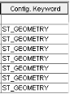
- Also copy the “EDGIS.PGE_APPSETTING”, “EDGIS.PGE_CONFIG”, and “SDE.TELVENT_VALIDATION_SEVERITY” tables. Ensure to login and paste as the appropriate user (i.e. EDGIS or SDE), and change the Config to ST_GEOMETRY.
- Execute an ArcFM xml export of the electric database in the SDE schema making sure to check all options to export.
- Delete the SubstationDataset from the electric database.
- Delete the following substation tables as well
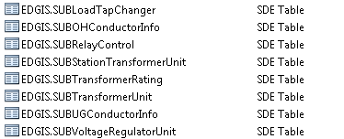
- Connect via sqlplus to the electric database as the EDGIS user and execute the following sql.
http://edappgistfsprd1:8080/tfs/ElectricDistCollection/EDAMGIS/_versionControl#path=%24%2FEDAMGIS%2FSource_Development_10_2_1%2FDocumentation%2F10.2.1+Upgrade%2FCreateSUBCircuitSource.sql&_a=contents
- Copy the new SUBCircuitSource table from the Electric database to the substation database via ArcCatalog. Delete the SUBCircuitSource table from the Electric Database
- Rename the SUBCircuitSource table to CircuitSource in the substation database
- Open the Esri properties of the CircuitSource table. Add a new field with the following properties
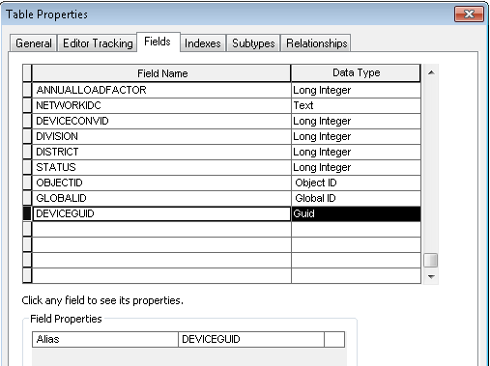
- Connect via sqlplus to the substation database as the EDGIS user
http://edappgistfsprd1:8080/tfs/ElectricDistCollection/EDAMGIS/_versionControl#path=%24%2FEDAMGIS%2FSource_Development_10_2_1%2FDocumentation%2F10.2.1+Upgrade%2FUpdate_SUBCircuitSource.sql&_a=contents
- Connect via sqlplus to the substation database as the SDE user
http://edappgistfsprd1:8080/tfs/ElectricDistCollection/EDAMGIS/_versionControl#path=%24%2FEDAMGIS%2FSource_Development_10_2_1%2FDocumentation%2F10.2.1+Upgrade%2FGDBM_Create_Schema_Oracle.sql&_a=contents
- In ArcCatalog delete the deviceguid2 field on the CircuitSource table.
- Back in ArcCatalog, right click on the newly created tables
DBM_NO_RECONCILE_VERSIONS,GDBM_PROCESS_LOG,GDBM_VERSION_DELETE_QUEUE,GDBM_POST_QUEUE, SUBEDGIS.GDBM_RECONCILE_HISTORY, and GDBM_POST_HISTORY in the substation database and choose Manage->Register with Geodatabase. Choose “Use existing field as OID”
- Right click again on the newly created CircuitSource table in the substation database and choose Manage->Add Global IDs.
- Create a new relationship between the SUBElectricStitchPoint and CircuitSource.
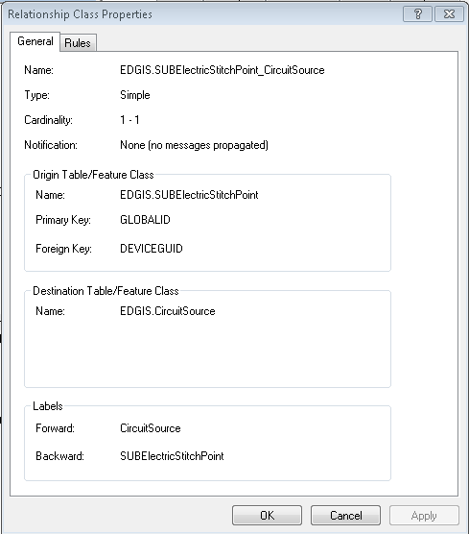
- Log in via sqlplus to the electric database as the EDGIS user and execute the following sql to remove invalid entries from the CircuitSource table.
http://edappgistfsprd1:8080/tfs/ElectricDistCollection/EDAMGIS/_versionControl#path=%24%2FEDAMGIS%2FSource_Development_10_2_1%2FDocumentation%2F10.2.1+Upgrade%2FUpdate_CircuitSource.sql&_a=contents
- Execute “Create/Update ArcFM Solution system tables” in the substation database as the SDE user.
- Execute the “Upgrade ArcFM Solution Database” in the substation database.
- Connect via sqlplus as the sde user to the substation database and execute the GrantMMTablePrivileges.sql script
- Import the previously exported xml file using the ArcFM xml import command in the substation database
- Right click the substation dataset and select Register As Versioned.

SECTION 03: Configure Electric Geometric Network to use Feeder Manager 2.0 (EDER)
- Right click on “EDGIS.ElectricDistNetwork” and choose configure feeder manager.
- Uncheck “Feeder Manager 1.0” (click OK to warning)
- Check “Feeder Manager 2.0” (click OK to warning)
- Click show advanced configuration
- Click the “Hide Feeder Manager 1.0 Fields” check box.
- Click the “Automatic cleanup of local storage files for feeder info” check box.
- Set to 1 day.
- Click the “Feeder Manager 1.0/Feeder Manager 2.0 Field Sync check box
- Click the “Enable Autoupdaters during field sync” check box.
- Set Target version for Sync to “SDE.DEFAULT”
- Click OK
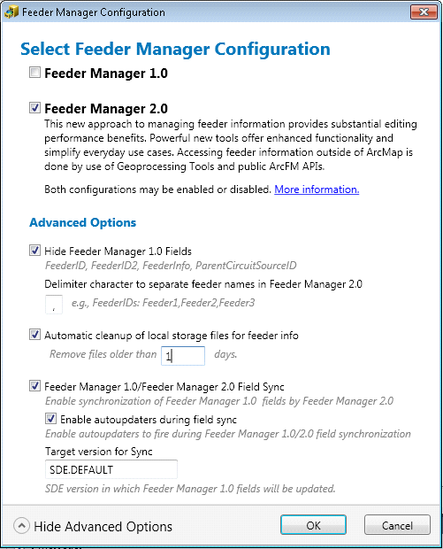
- Add the “PGE_MM_EDITED_FEATURES” domain value to the “PGE OBJECT CLASS MODEL NAMES” domain.
- Add the “PGE_MM_EDITED_FEATURES” class model name to the “SDE.MM_EDITED_FEATURES” table.

SECTION 04: Configure Substation Geometric Network to use Feeder Manager 2.0 (EDERSUB)
- Right click on “EDGIS.SubGeometricNetwork” and choose configure feeder manager.
- Uncheck “Feeder Manager 1.0” (click OK to warning)
- Check “Feeder Manager 2.0” (click OK to warning)
- Click show advanced configuration
- Click the “Hide Feeder Manager 1.0 Fields” check box.
- Click the “Automatic cleanup of local storage files for feeder info” check box.
- Set to 1 day.
- Click the “Feeder Manager 1.0/Feeder Manager 2.0 Field Sync check box
- Click the “Enable Autoupdaters during field sync” check box.
- Set Target version for Sync to “SDE.DEFAULT”
- Click OK
- Add the “PGE_MM_EDITED_FEATURES” domain value to the “PGE OBJECT CLASS MODEL NAMES” domain.
- Add the “PGE_MM_EDITED_FEATURES” class model name to the “SDE.MM_EDITED_FEATURES” table.
Drop Triggers from Substation Database
- Log into the substation database as SDE through SQLPLUS and run the following lines of SQL:
  - Drop trigger PGE_NONDEFAULT_TRIGGER_INSERT;
  - Drop trigger PGE_NONDEFAULT_TRIGGER_UPDATE;
  - Drop trigger PGE_DEFAULT_TRIGGER_INSERT;
  - Drop trigger PGE_SDEDEFAULT_TRIGGER;

SECTION 05: Relationship Class Changes (EDER)
- Log into ArcCatalog to the Electric database.
- Right click on the EDGIS.ProtectiveDevice_Generator relationship class and choose properties
- Click on the rules tab
- Configure so it looks like the following and click Apply -> OK.
- Repeat for the EDGIS.Transformer_TransformerUnit relationship class. Set the following values in the screenshots below.

SECTION 06: EDER Views (EDER / EDERSUB)
For this section only, steps 1-5 needs to be run from an ArcGIS 10.0.3 machine with SP5 and ArcSDE installed.
- Log into the electric database (EDER) from a 10.0 machine.
- Ensure that views starting with “ZZ_MV_*” appear in the root level of the database.
- Ensure that no views with the suffix of “*_EVW” appear in the root level of the database.
- If the _EVW views exist:
  - Open the following script from TFS and change the username, password, and database to the desired values.
$/EDAMGIS/Source_Development_10_2_1/Documentation/10.2.1 Upgrade/MVVIEWS-Drop_and_Create_using_ZZ_MV_for_EDGIS.sql

  - Execute the script from the command prompt on a machine with ArcSDE 10.0 SP5 installed. This must have SP5 with the latest patches for October to connect to the database and create the right view.

- Repeat the above Views steps for the substation database (EDERSUB).

SECTION 07: Grant Privileges (EDER / EDERSUB)
*Return to using a 10.2.1 machine with all documented patches installed.
- Modify the data source in the grant_privs.py script and run the script against both the Substation and EDER databases as the EDER user.
- Connect via sqlplus as the edgis user to the substation database and execute the GrantEDTablePrivileges.sql script

SECTION 08: Process Framework Configuration Changes (EDER)
- Open the Process Framework Administration tool
- Login in to the desired database as the process user
- Click the Node Types tab
- Select the Post Session task
- Click Properties
- A message regarding removing the Device group subtask should be presented.
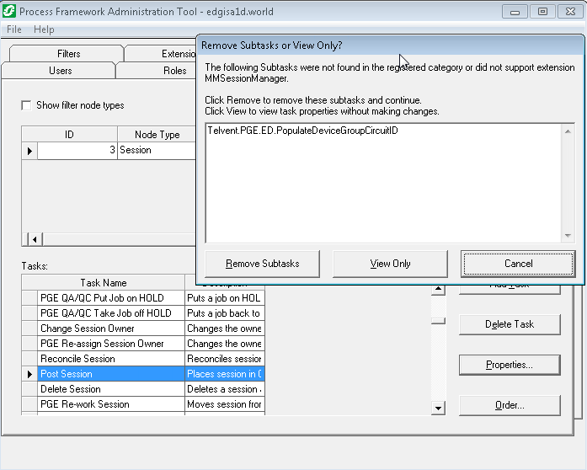
- Click Remove Subtasks
- Click OK
- Click File-> Save

SECTION 09: Create WEBR CircuitSource views (EDER)
Follow instructions at
\\sfetgis-nas01\sfgispoc_data\ApplicationDevelopment\IBM_Delivery\Releases\WEBR\EDVIEWER_v2.0.0\create_circuitsource_views.txt

SECTION 10: Apply permissions for GIS_I (EDERSUB)
Assign permissions to gis_i user on edersub. Use the following python, replacing the path to a password-saved SDE file as appropriate
import arcpy
arcpy.ChangePrivileges_management("'c:/eder/data/connections/edgis@edersub.sde/EDGIS.SubstationDataset';'c:/eder/data/connections/edgis@edersub.sde/EDGIS.SUBLoadTapChanger';'c:/eder/data/connections/edgis@edersub.sde/EDGIS.SUBOHConductorInfo';'c:/eder/data/connections/edgis@edersub.sde/EDGIS.SUBRelayControl';'c:/eder/data/connections/edgis@edersub.sde/EDGIS.SUBStationTransformerUnit';'c:/eder/data/connections/edgis@edersub.sde/EDGIS.SUBTransformerRating';'c:/eder/data/connections/edgis@edersub.sde/EDGIS.SUBTransformerUnit';'c:/eder/data/connections/edgis@edersub.sde/EDGIS.SUBUGConductorInfo';'c:/eder/data/connections/edgis@edersub.sde/EDGIS.SUBVoltageRegulatorUnit';'c:/eder/data/connections/edgis@edersub.sde/EDGIS.CIRCUITSOURCE'","gis_i","GRANT","#")

SECTION 11: Update Cached Tracing Tables (EDER / EDERSUB)
Ref: Change Request 20558: Update Cached Tracing tables
With the PGE Tracing Cache installer at 10.2.1, changes were made to the underlying stored procedures. The updated SQL script must be run.
1. Log in via sqlplus as the EDGIS user to the desired Electric database (EDER).
2. Execute the following sql script.
\\sfetgis-nas01\sfgispoc_data\ApplicationDevelopment\IBM_Delivery\10.2.1\Releases\Cached Tracing\10.2.1.1\EDCachedTracing.sql
3. Log in via sql plus as the EDGIS user to the desired substation database (EDERSUB).
4. Execute the following sql script
\\sfetgis-nas01\sfgispoc_data\ApplicationDevelopment\IBM_Delivery\10.2.1\Releases\Cached Tracing\10.2.1.1\SUBCachedTracing.sql

SECTION 12: APPENDIX, INTERFACES AND OTHER REFERENCE TICKETS
Configuration Steps to enable ST_Geometry sql commands on database server
- Rob Rader to fill in

Upgrade WIP Database
Follow instructions at:
\\sfetgis-nas01\sfgispoc_data\ApplicationDevelopment\IBM_Delivery\Other\Wip1021\upgrade_wip_readme.txt

Kris/Roger to vet this list of TFS tickets to see which are included in 9.6 and 9.6.1 and may not need to be executed.
List Additional TFS CRs that need to be applied to the EDER database are listed below:
- Change Request 20420:Remove ArcFM Structure Relate from DCRectifier and DistBusBar
- Change Request 20459:Add CircuitColor field to tables
- Change Request 20558:Update Cached Tracing tables
- Change Request 20589:ED50 Configuration for EDGIS.NetworkProtector
- Change Request 20768:Modify ArcFM Properties to support Circuit ID UI
- Change Request 20611:Add new Source Side Device Fields and Configure

For all installation instructions below, only execute on those servers where a particular installation is needed. Individual TFS tickets will need to be created for each server installation and can use the template TFS tickets outlined below.

GDBM Installation and Configuration Changes: *Needs to happen after Desktop and ED06 has been installed / Base Software.
- Change Request 22024:10.2.1 GDBM Installation and Configuration Changes

Installation instructions for 10.2.1 custom installers by component

Cached Tracing
- Change Request 22025:10.2.1 Cached Tracing installation and configuration
EDER Desktop
- Change Request 22028:10.2.1 EDER Desktop Installation

ED06
- Change Request 22030:10.2.1 ED06 Installation and Configuration

ED07
- Change Request 22031:10.2.1 ED07 Installation and Configuration

ED08
- Change Request 22032:10.2.1 ED08 Installation and Configuration

ED013

- Change Request 22033:10.2.1 ED013 Installation and Configuration

ED50
- Change Request 22035:10.2.1 ED50 Installation and Configuration

Map Production 2.0

- Change Request 22036:10.2.1 Map Production 2.0 Installation and Configuration

Change Detection
- Change Request 22041:10.2.1 Change Detection Installation and Configuration

